**Documentation – Golden Gate Assembly of PPRs**

**Binding code:**

|  |  |  |  |
| --- | --- | --- | --- |
| **A = TN** | **G = TD** | **C = NN** | **T = ND** |

**Naming convention:**

Modules are denoted with a **number representing their group.** PPR modules are followed by a **letter (A-E)** representing their **order** in the PPR. In addition, the **binding residues** making up the PPR code are included as they appear, 5’ to 3’.

Example: **1D_DT**: Group 1, module D, containing D (**Last AA**) and T (**Fifth (5) AA**).

**Note:** AAs are written as **Last > Fifth**, and the PPR code is **Fifth > Last**. In order to construct a PPR protein, the code must be considered **for** **assembled modules**

**Catalogue:**

**Table 1:** Basic PPR modules containing **only** motifs. **Count: 36 unique parts\*\***

|  |  |  |  |  |  |  |  |  |
| --- | --- | --- | --- | --- | --- | --- | --- | --- |
|  | **Group 1** | | | | **Group 2** | | | |
| **A\*** | 1A_N | | 1A_T | | 2A_NT | 2A_NN | 2A_DT | 2A_DN |
| **B** | 1B_NT | 1B_NN | 1B_DT | 1B_DN | 2B_NT | 2B_NN | 2B_DT | 2B_DN |
| **C** | 1C_NT | 1C_NN | 1C_DT | 1C_DN | 2C_NT | 2C_NN | 2C_DT | 2C_DN |
| **D** | 1D_NT | 1D_NN | 1D_DT | 1D_DN | 2D_NT | 2D_NN | 2D_DT | 2D_DN |
| **E\*** | 1E_NT | 1E_NN | 1E_DT | 1E_DN | 2E_N | | 2E_D | |

**\* Group 1 A modules** contain a solvating helix, and so only have **1 binding residue**

* **Group 2 E modules** terminate the SS-PPR sequence with the **last binding residue**

**\*\*** A system to expand the PPR’s size by adding additional blocks of 5 modules **between Group 1 and Group 2** is in the planning stage. The implementation of this system requires **8 additional parts** per block of motifs that may be added

**Complete PPR:** 1A-1B-1C-1D-1E|2A-2B-2C-2D-2E|(3P2L2S2|4E1E2DYW)

**Table 2:** P2L2S2 modules. **Count: 16 unique parts**

|  |  |  |  |  |
| --- | --- | --- | --- | --- |
|  | **Group 3** | | | |
| **v P2 / S2 >** | **TN** | **TD** | **NN** | **ND** |
| **TN** | 3P2L2S2_TNTN | 3P2L2S2_TNTD | 3P2L2S2_TNNN | 3P2L2S2_TNND |
| **TD** | 3P2L2S2_TDTN | 3P2L2S2_TDTD | 3P2L2S2_TDNN | 3P2L2S2_TDND |
| **NN** | 3P2L2S2_NNTN | 3P2L2S2_NNTD | 3P2L2S2_NNNN | 3P2L2S2_NNND |
| **ND** | 3P2L2S2_NDTN | 3P2L2S2_NDTD | 3P2L2S2_NDNN | 3P2L2S2_NDND |

**Note:** in future iterations, the P2L2S2 (and by extension, the E1E2DYW) are intended to be optional

**‘Group 4’**

CTDs, such as the E1E2DYW block, will be classified here. Currently, only the **E1E2DYW** has been designed, but providing the correct overhangs are inserted, anything may be appended instead (for example, a nuclease).

**Potential:** the PPR’s binding site may be included as a ‘Group 5’ module. These would probably have to be synthesised externally, as the idea doesn’t really work in a kit.

**Target Vector:**

For ease of cloning, a medium-copy level M vector containing a **BsaI-excisable** ‘CDS dummy’ (lacZa) has been designed. Currently, this is the only design available, and altering the promoter, N-tags, or terminator would require a completely new insert (1136bp)

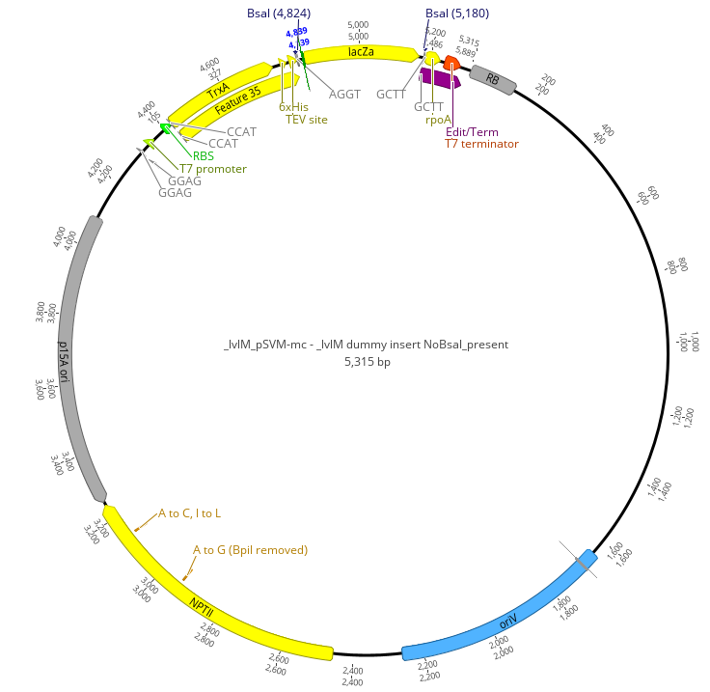

**Fig:** level M vector with excisable insert

**Assembly Protocol 1: Short Assembly: Level 0 to Level M**

1. Clone custom **‘dummy insert’** (containing the promoter, N-tag(Trx, 6His, TEV site), LacZ ‘CDS’, and edit site/terminator region) into **level M vector (pSVM-mc)** using **BpiI**
2. Clone PPR **level -1** portions into **level 0 plasmid (pAGM9121)** using **BpiI.** The result will be: GROUP 1 plasmid, GROUP 2 plasmid, GROUP 3 P2L2S2 plasmid, and GROUP 4 E1E2DYW plasmid.
3. Transfom *E. coli*, propagate, and prepare plasmids.
4. Mix five prepared plasmids. Digest with **BsaI** and ligate.
   1. Here, the LacZ insert will be digested out, and the level 0 PPR portions ligated in in order
5. Transform and propagate, then prepare.

**Result:** Level M medium-copy plasmid containing a gene capable of transcribing a custom PPR-DYW